Progress & Delivery report
For: Client
Function:

By: First / Last name
Title:
Contact details:

Introduction
We appreciate you entrusting QTC with this role. We see each assignment as a collaboration with the goal of providing qualified applicants and market intelligence so that hiring choices may be made with confidence.

This report offers multiple main objectives
- Openness on the search procedure and market reaction.
- A selection of applicants who fit the job specifications and corporate culture.
- Market insights, offering an overview of trends, candidate availability, and relevant developments within the market.
- Process & figures, presenting key metrics and data related to the recruitment process, such as outreach, responses, and progress.
- Selected candidates, highlighting applicants who best match the job specifications and align with the company’s culture and requirements.

By combining process transparency with clear candidate profiles, our aim is to give you the clarity needed to move forward quickly and decisively.

Our Search Philosophy: Built on Process, Designed for Precision
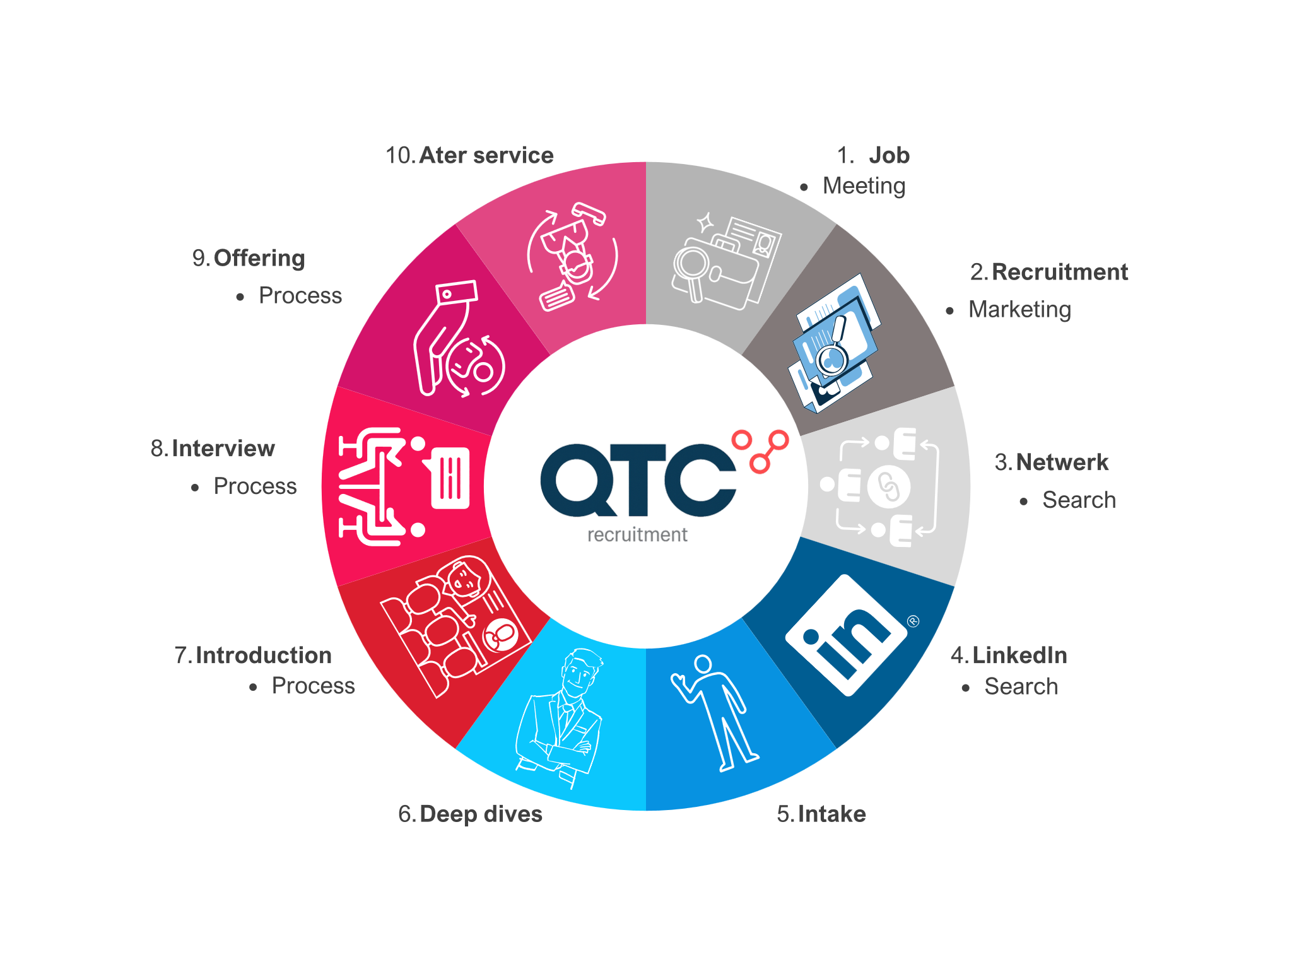
Our methodical 10-step approach, that includes Lean Six Sigma concepts and more than 20 years of Life Sciences experience, guarantees quality, efficiency, and ongoing progress.

What this means for your organisation:

- Structured job intake and benchmarking to clarify expectations and candidate fit.
- Precision targeting through talent pools, LinkedIn campaigns, and referrals.
- Market feedback loops from day one, adapting quickly to candidate response and sentiment.
- In-depth shortlisting that looks beyond technical skills to leadership traits, motivation, and long-term alignment.

This strategy produces applicants that fit the job requirements and can help your business succeed in the long run.

Campaign Performance & Market Response Overview

This assignment's initial goal was to find and involve experts who might effectively contribute to Client Company Name]’s [insert role essence, e.g. “scaling commercial operations across EMEA”].

QTC Recruitment launched a focused search strategy using three main channels, a defined approach, and its Life Sciences network.

- Direct identification through our 300,000+ Life Sciences profiles, supported by curated warm lists and referrals.
- Targeted outreach via LinkedIn Recruiter and personalised contact with trusted connections.
- Public activation; With more than 250,000 members throughout Europe and beyond, QTC's network initiates public recruiting via LinkedIn positions and specialist communities in MedTech, Diagnostics, Food Science, and Biotech/Pharma.

This strategy guarantees that the most qualified experts are given consideration for the position and enables us to interact with both active and passive candidates.

Key metrics around position:

Activity | Results
Job post live date
Days role was live
Applicants (job vacency)
1e conversations held
2e conversations (deep-dive)
Shortlisted
Avg.time to shortlist
Delivery ratio

Consultant Interpretation
- Role positioning: The answer from the candidate indicates a high level of interest. [Client's growth/science/story] is one of the strengths mentioned, but [salary/scope/location] were identified as the primary concerns.
- Funnel quality: Outreach produced more qualified profiles than direct applications, resulting in a targeted shortlist that fits the job.
- Process & ratios: Tight targeting was demonstrated by the effective conversion from outreach to shortlist. The current diversity ratio is [##/##], which might help choose which backup options to consider if balance is crucial.
- Market signal: The position is competitive in the market, but it may gain more momentum if [salary, flexibility, and message] are changed.

Shortlist snapshot:

Candidate | Location | Salary | Key Skills and Experiences | Availability | Education
{% for candidate in shortlist_snapshot %}{{ candidate.name }} | {{ candidate.location }} | {{ candidate.salary }} | {{ candidate.key_skills_experience }} | {{ candidate.availability }} | {{ candidate.education }}{% endfor %}

Candidate introduction:

{% for candidate in candidate_introductions %}
{{ candidate.header }}

{% for bullet in candidate.bullets %}
- {{ bullet }}
{% endfor %}
- Motivation: {{ candidate.motivation }}
- {{ candidate.practical }}

{% endfor %}

Final Suggestion:
{{ final_suggestion }}

